FUND MANAGERS

by Joe Marsh | 1 day ago

# Warning sounded on credit fund concentration risks

Allocations to funds based on corporate bond indexes raise issues that investors seem unaware of, such as US high yield's correlation to the oil price, according to new research.





↑





Energy risk: US high-yield bonds are highly correlated to the oil price

The downsides of investing based on traditional market cap-based equity indexes are well documented, but many investors do not realise that credit markets face similar issues, said Raphael Thuin, fixed income portfolio manager at Tobam, a Paris-based smart-beta fund house.

As a stock's value rises, so does its weight in an market cap-weighted equity benchmark, he noted, and the same is true of corporate bonds, posing significant concentration risks to both passive and active managers.

Hence many investors are exposing themselves heavily to very specific risk factors when they buy corporate bond funds, he told AsianInvestor, citing new research by Tobam.

Thuin said the research highlighted several risks: the high correlation of US high yield with the energy sector in the past year or so; the fact that credit spreads are very tight and not highly dispersed; and the concentration of almost half the US high-yield bond market in the hands of just 20 asset managers.

As a result, he argued, investors should take a more diversified approach to corporate bonds than simply allocating to traditional active or passive credit funds.

Thuin said Tobam’s ‘diversification ratio’ could help: it is a quantitative formula designed to ensure a portfolio is as diversified as possible and avoids the concentration risk posed by traditional index-based or benchmarked investments.

The three findings

One concern raised by Tobam’s research is the high correlation of certain countries' credit markets with specific sectors at certain times.

During the technology, media and telecommunications (TMT) boom in the US in 2000, companies in the sector issued bonds to finance growth, noted Thuin (see figure below). That meant the debt in that sector increased to almost 45% of the total high-yield market at the time on a risk-adjusted basis (32% of its market-value) – before the TMT bubble abruptly burst.

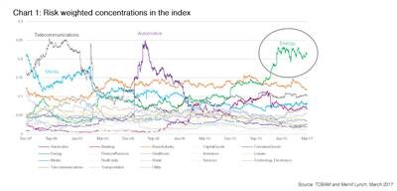

Risk-weighted concentrations (click for full view)

It was a similar story in 2005 for the US automobile industry, said Thuin, “and now the elephant in the room is the energy sector”.

The 2007-2008 shale gas boom in the US spurred energy companies to finance growth; hence the increased weight of the energy sector in credit indexes. The upshot is that the most popular US high-yield exchange-traded fund, iShares’ HYG, has had a correlation as high as 80% to the oil price in the past year or two, said Thuin: “US credit investors may not realise it, but they are at times basically buying barrels of oil.”

This is worrying, he noted, as energy-sector bonds have rallied strongly in 2016, massively outperforming the market, despite a still very bleak operational environment for energy companies and a spike in defaults to nearly 25% late last year.

On the back of this rally, the big spread pick-up that investors used to get to take the energysector credit risk has now all but disappeared, said Thuin, putting the market’s largest concentration – and market participants – at risk.

Asian credit faces a similar problem in that it is very highly correlated to property, he said – above all to Chinese developers. As of July 31, real estate firms accounted for 40.7% of the Bank of America High-Yield Asia Emerging Market.

Another risk factor that Thuin flagged was that of global credit spread dispersion being at historically low levels, limiting investors’ ability to generate alpha. Spread dispersion is now comparable to its level in 2006 and 2007, the years preceding the global financial crisis, he said.

The third credit market issue he raised was that of concentration among fund houses: in high yield, the 20 biggest managers own close to half of the market, by eVestment data (see figure below).

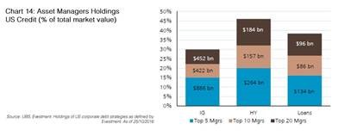

Asset managers' US credit holdings (click for full view)

“A handful of guys are calling the shots on market moves,” said Thuin. “The big players are so big now that they are basically driving the market.” This creates uncertainty for the investor and could make tactical allocations hazardous, argued Tobam in its research.

The trend for consolidation in the asset management industry – consider the three big mergers in the past year alone to form Aberdeen Standard, Amundi Pioneer and Janus Henderson – is only like to exacerbate this issue.

Source: ¬ Haymarket Media Limited. All rights reserved.