**TOBAM awarded by Funds Europe for the 4th consecutive year**

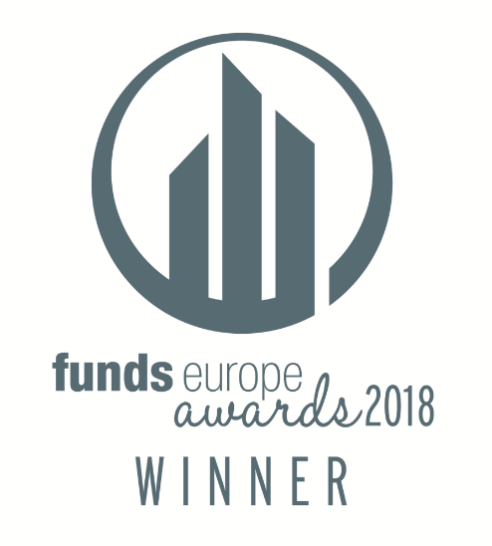**2015 – “European CIO of the Year” *- Yves Choueifaty***

**2016 – “European Asset Manager of the Year*”**



**2017 – “European Asset Manager of the Year*”**



**2018 – “European Smart Beta Provider of the Year”**

We are pleased to announce that TOBAM has been awarded **“*European Smart Beta Provider* *of the Year*”** at the 14th **Funds Europe Awards** ceremony on the 1st of November 2018 in London.

The Funds Europe Awards, one of the most prestigious in the asset management industry, sets out to recognise personal and **company achievements and contributions within the European funds community** and to credit publicly those who have advanced the cross-border agenda in the funds industry. Excellence in Business is the byword.

Judges score entries for excellence, demonstrated in these key areas: **performance, growth, innovation, development, client service and commitment to Europe and the industry**. Notably, to be awarded as the **“*European Smart Beta Manager of the Year*”**, a judges panel, composed of leading professionals with a wealth of funds industry experience, look for exceptional performance within the categories mentioned previously during the twelve-month period (June 2017 to June 2018).

This marks the **fourth year in a row that TOBAM has been chosen for a Funds Europe award**, which also makes it the fifth award in total to be awarded to TOBAM by Funds Europe (“*Special commendation to the asset manager of the year*” in 2014, “*European CIO of the Year*” in 2015 and “*European Asset Management Firm* of the Year*” in 2016 & 2017)

TOBAM is nominated as a finalist in the **CiO Industry Innovation Awards**, in the “*Fixed Income/Credit*” category. Results for the CiO Industry Innovation awards will be announced on December 13th 2018 in the New York Library.

*: AuM below €20bn category